|  |  |
| --- | --- |
| History of Rebetiko |  |

# The origins - social and music conditions

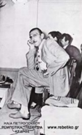It has been suggested that the origins of rebetiko are connected with the songs of prison. The first reference to the songs of prison goes back to the middle of the 19th century. In 1850 the French nobleman Appair visited Greece in order to study the problem of the Othonian prisons and he referred to the songs that were heard there. Several others made a reference to these songs, such as Papadiamantis, Dafnis and Karkavitsas, who visits Moria in 1890 and in 1891 records in "Estia" magazine (a magazine published by G. Drosinis) several of them.

From the establishment of the neo-Hellenic state up to about 1880, the Italian opera dominates in Athens. All "Greek" songs of this period were based on the melodies of the Italian operas. The first attempt for the creation of Greek songs begins with the Ionian Islands serenade and the Athenian songs. Of course, the influence of the Italian opera is clear but assimilated to an extent so as not to be superficially presented.

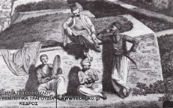In 1871 the Conservatory of Athens is established and the same year the first sandan-cafι opens in Athens. In 1873 the first sandur-cafι opens (from 1886 onwards the sandur-cafιs are renamed aman-cafιs). In 1880 Athens was divided into two. On the one side there were the "lovers of the Asian muse" and on the other side all those who believed that the long-drawn-out love songs (amane) had not at all Greek features. That led to many discussions concerning the music of the Orient. By 1886 Athens was full of aman-cafιs. The complete dominance of the long-drawn-out love song will last ten years. Towards the end of the century the decay of the aman-cafιs, the appearance of the shadow play and the Athenian revue are observed.

Along with this theatre genre, the love of the audience for the foreign music was rekindled. The music at the revues, apart from few "unsuccessful" cases, was a true copying of foreign melodies. The revue’s success was tremendous. It dominates over the first two decades of the 20th century. The revue’s content changes after 1922 and so do the audience’s interests.

After the Catastrophe in Asia Minor, the aman-cafιs return for a while but operetta dominates (from 1916 until 1928). Its music was Greek and it was not at all related neither to the revue nor to the "amanetzidika". In the 1930s the songs of the wine, which started being written during the first years of operetta, reach their pinnacle. Along with the appearance of discography, the theatre, which was the most mass way of communication, loses ground. This is the point where we should look for the reasons that led to the decay of operetta.

The kinds of music aforementioned arose in specific social conditions. Life in Greece, during that period, was determined by factors such as internal and external immigration, doubling of the Greek territories in 1912 and the Asia Minor Catastrophe in 1922. The refugees’ songs arose from the Asia Minor Catastrophe, in combination with the folk songs, the songs of the islands and the other kinds of music aforementioned became the substratum that led to the creation of rebetika.

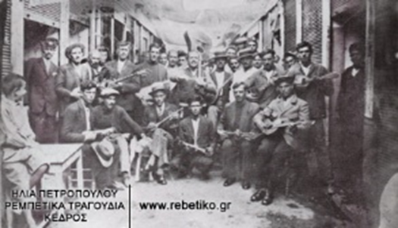

Rebetika are songs par excellence of the cities and especially of the ports, such as Smyrna, Constantinople, Syros, Thessaloniki, and Piraeus.

# Periods of rebetiko

## Until 1938

The first rebetika songs referred mainly to law-breaking actions and love affairs, while the social element is limited in the content. Over this period, the Piraeus style dominates, basically represented by Markos Vamvakaris. At the same time, Smyrniot composers also start composing rebetika songs. In 1937 Vasilis Tsitsanis appears as well as Manolis Hiotis, almost at the same period. In 1936 censorship is imposed by Metaxa's regime on the song "Varvara" by Tountas and in the following year a generalised censorship as rebetiko has its victim. The content necessarily changes. The references to hashish, opium dens and nargilehs are extinct.

## 1938 - ca. 1960 period

Songs are also written during the occupation; they are not recorded though, since the factories remain closed until 1946. Since then, Vasilis Tsitsanis along with Marika Ninou, Manolis Hiotis, Giorgos Mitsakis, Giannis Papaioannou dominate. But most of the old rebetes are pushed out of the limelight. During the Occupation, many of the Smyrniot composers (e.g. Panagiotis Tountas) die, but the others, the ones representing the Piraeus style, are alive and try to make a living with difficulty. Markos Vamvakaris mentions in his autobiography “he used to go to all the islands and the festivals”. New important singers appear in the 1940's (Sotiria Mpellou) and in the 1950's (Stelios Kazantzides and Grigoris Bithikotsis)

Rebetiko causes a sensation to increasingly greater parts of the population. This results in expanding its topics (arhontorebetika appear) and in changing the places it was heard. Most of the researchers conclude that rebetiko died in the mid-1950s.

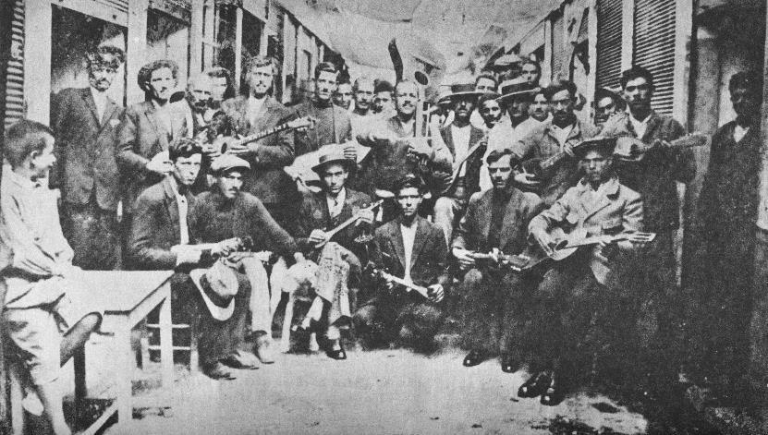

## 1960 onwards

In the 1960s rebetiko revives as a ghost. The articles, all the spirited efforts of several students, people’s satiety of the Indian songs, the recording of Theodorakis’s Epitafios in 1960 had as a result for the record companies to start recording rebetika anew. Some old ones were recorded, mainly sung by Grigoris Bithikotsis and Sotiria Bellou. The rebetes (the singers of rebetika), such as Markos and Stratos, got a job in the entertainment places again. In the meanwhile, music nights with rebetika songs started being organized, where people, mainly students, had the opportunity to meet old rebetes singers. In 1961 Hristianopoulos circulates an essay and therefore he claims the triple title of honour: for the first rebetika literature, for the first anthology of rebetika versification and, as far as its reprinted form is concerned, for the first monograph on this subject-matter. In 1968 Elias Petropoulos’ book “Rebetika songs” circulates. That was the book that established the term “rebetika” regarding these songs. At the beginning of the 1970s some of the greatest rebetes die (Stratos 1971, Markos 1972).

Since then most rebetes started recording, biographies were published (Vamvakaris 1973, Rovertakis 1973, Roukounas 1974, Tsitsanis 1979, Mouflouzelis 1979 etc) and many bands appear. At the same time centres for the study of the rebetika songs were established and the university Folk Science scientists start mentioning it.

In the 1980s films are made (K. Ferri’s Rebetiko with songs whose topics and music resemble the rebetika songs), television series (Minore tis Avgis: The Minor of the Dawn), revues (Minore tis Allagis: The Minor of the Change).

In 1984 Vasilis Tsitsanis dies and its funeral is held at public expense. Some believe that rebetiko died. But some say: How can a kind of song that is still sung to be considered to be dead?

# Matters of Study

## Social context

The columnists try to set boundaries to the social framework on which the rebetiko was created. Underworld offenders, lumpen, lumpen-proletariat, breaking the law for a short time, proletarianization of the rural class, violent urbanization are some of the reasons that are highlighted. However, most of the rebetes do not consider their songs to be expression of the underworld.

## Chronology

The chronology of the origins of rebetiko is still a matter that is hard to solve. Some believe that rebetika songs originated in Byzantium, others in the middle of the 19th century, while others in the period between 1920 and 1940.

## Musical Instruments

Rebetiko used several musical instruments. The main one though was bouzouki. For the Greek character of bouzouki (and the musical ways used for the songs’ composing) the researchers’ views diverge. Some characterize it as an instrument that is not Greek and has limited potentials; other claim that its origin goes back to ancient Greece. The first sound recording of bouzouki is another point of disagreement for the researchers

## The term rebetika

In order to refer to these songs we use the term rebetika. The term prevailed against others (karipika, magkika, mortika, etc) and was introduced relatively late. The first time it was used was for the recrords’ tags in order to describe songs that were quite different from each other. Even in the songs that we nowadays name rebetika the words rebetis and rebetika appear for the first time about in 1935.

At this point we must mention that realist novelists of the later 19th century describe the marginal life of the cities by using, for their characters, words like mangas, alanis, mortis, vlamis, asikis, xasiklis, but not the word rebetis. They also refer to koutsabakides, who were active in the second half of the 19th century and used to sing with lyrics taken from folk songs. The same lyrics are recorded later as "rebetika".   
A matter that remains unsolved even nowadays is the origin of the word rebetis (the singer of rebetika). At the beginning of the relevant discussions not much attention was paid to the origins of the word. However, later they tried to set boundaries to the social framework that rebetiko created by using the etymology. The effort did not reach a satisfactory point.